**Validating credit card-99003194**

class starting:

def _init_(self, num):

self.num = num

self.obj5 = self.master()

def check_visa(self, num):

if num[0] == '4':

return True

else:

return False

class master:

def _init_(self):

self.num = num

def check_Master(self, num):

if num[0] == '5':

return True

else:

return False

def check_Discover(self, num):

if num[0] == '6':

return True

else:

return False

def check_American(self, num):

if num[0] == '3':

return True

else:

return False

class length:

@classmethod

def val_len(cls, num):

if "-" in num:

s = len(str((num)))

if(s == 19):

return True

else:

return False

else:

s = len(str((num)))

if(s != 16):

return False

else:

return True

class digit:

@staticmethod

def val_isdigit(num):

for i in num:

if not (((i >= '0') and (i <= '9')) or (i == '-')):

return False

break

else:

return True

break

class group(starting, length, digit):

def _init_(self, num):

self.num = num

def val_group(self, num):

if "-" in num:

list1 = num.split("-")

if(len(list1) == 4):

if(len(list1[0])) == 4:

return True

if(len(list1[1])) == 4:

return True

if(len(list1[2])) == 4:

return True

if(len(list1[3])) == 4:

return True

else:

return False

super(). _init_()

card_number = input("enter card number: ")

obj1 = starting()

obj2 = length()

obj3 = digit()

obj4 = group()

obj5 = obj1.master()

choice = int(input("Enter user choice:"))

if choice == 1:

print("Checking User card is visa or not")

result = [obj1.check_visa(card_number), obj2.val_len(card_number),

obj3.val_isdigit(card_number), obj4.val_group(card_number)]

if False in result:

print("invalid")

else:

print("valid")

elif choice == 2:

print("Checking User card is Master or not")

result = [obj5.check_Master(card_number), obj2.val_len(card_number),

obj3.val_isdigit(card_number), obj4.val_group(card_number)]

if False in result:

print("invalid")

else:

print("valid")

elif choice == 3:

print("Checeking User card is Discover or not")

result = [obj1.check_Discover(card_number), obj2.val_len(card_number),

obj3.val_isdigit(card_number), obj4.val_group(card_number)]

if False in result:

print("invalid")

else:

print("valid")

elif choice == 4:

print("Checking User card is American express card or not")

result = [obj1.check_American(card_number), obj2.val_len(card_number),

obj3.val_isdigit(card_number), obj4.val_group(card_number)]

if False in result:

print("invalid card")

else:

print("valid card")

else:

print("none")

**Screenshot:**

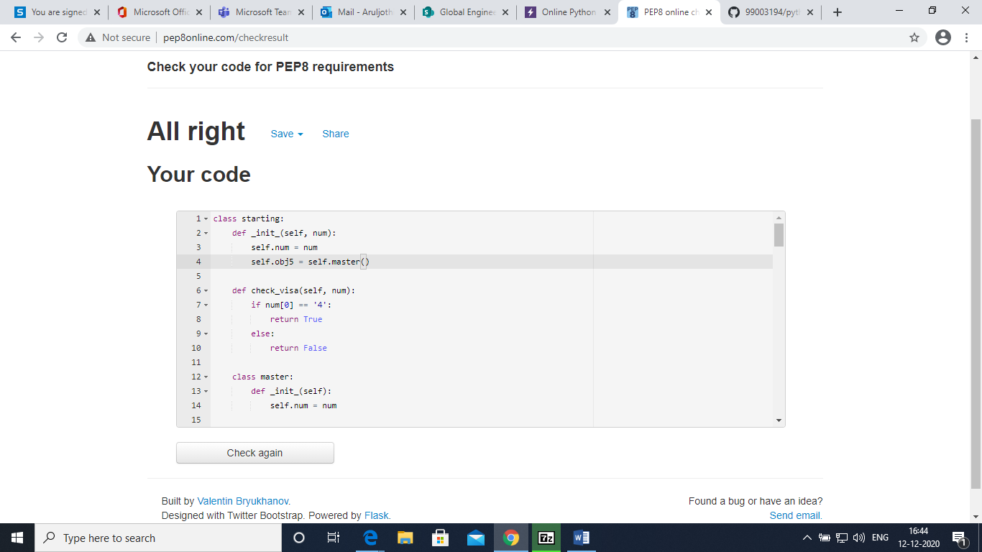

**Regular expression:**

import re

print(re.match("[a-z A-Z]+","Validating credit card))

**Screenshot:** 